Lab 15: Cross-site scripting - Stored
Objective:
- This lab is focused on Stored Cross-Site Scripting (XSS) vulnerabilities, a type of XSS where malicious scripts are permanently stored on the target server, such as in a database, and then rendered in a user's browser when the stored data is displayed. Participants will interact with a simulated web application that is vulnerable to stored XSS attacks.
In this lab, students need to:
- Answer the following questions:
  - What defines Stored Cross-Site Scripting (XSS), and how does it differ from Reflected XSS and DOM-Based XSS?
  - Explain the process of how malicious scripts are injected, stored, and subsequently executed in Stored XSS attacks, and discuss the potential consequences these attacks can have on both users and web applications.
- Perform challenge:
  - Stored DOM XSS
- Explain and capture all steps (full windows screen capture).
Group Members:
- Phạm Hoàng Hải Nguyên (SE180511)
- Nguyễn Trúc Quỳnh (SE180280)
- Giã Thị Nhã Trân (SE180405)

Submit a report addressing all the questions mentioned above in either PDF or Markdown format. Additionally, include a video demonstrating the detailed process of your work to ensure the authenticity of your lab exercise.
The report file name must be Class_YourStudentID _YourName_Lab15

Stored DOM XSS
The left side shows Burp Suite with the HTTP history tab empty, indicating that no requests have been captured yet, which usually happens when the proxy is not configured properly or traffic has not been routed through Burp, while the right side displays the “Stored DOM XSS” lab from PortSwigger, including the lab description and instructions for exploiting the vulnerability using an XSS payload.
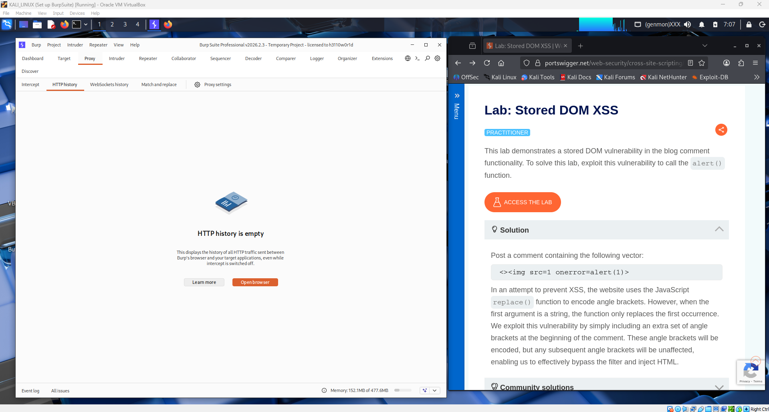

The left side shows Burp Suite with multiple HTTP requests captured in the HTTP history tab, indicating that the proxy is now properly configured and traffic from the browser is being intercepted, while the right side displays the target blog page from the lab where user interactions such as viewing posts or submitting comments can be used to test and exploit the Stored DOM XSS vulnerability.
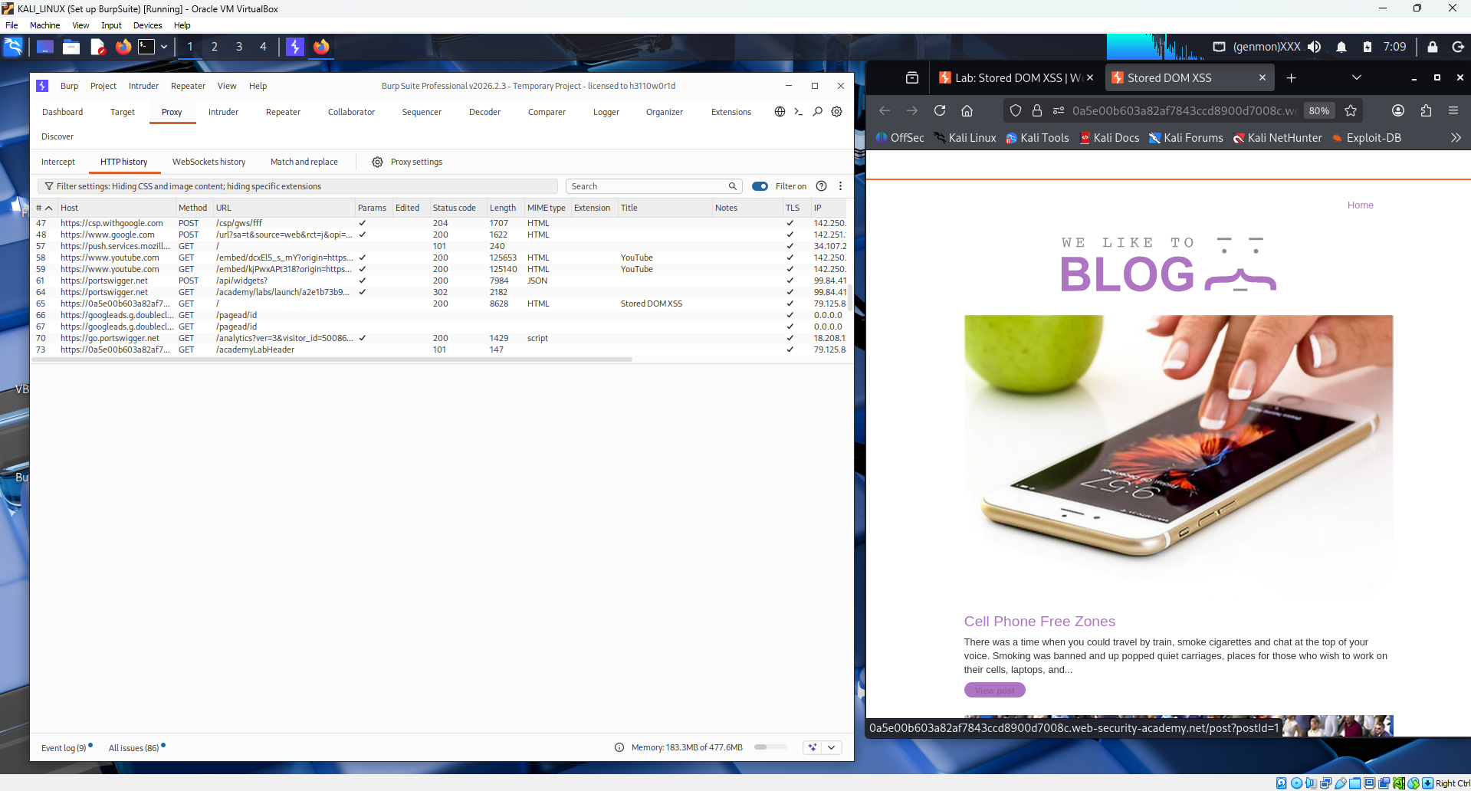
The left side shows Burp Suite with a specific request selected and detailed information displayed in the Request and Response panels, allowing analysis of how the web application processes data, while the right side shows the blog post page where user input, such as comments, can be tested for Stored DOM XSS by observing how injected scripts may be rendered and executed.
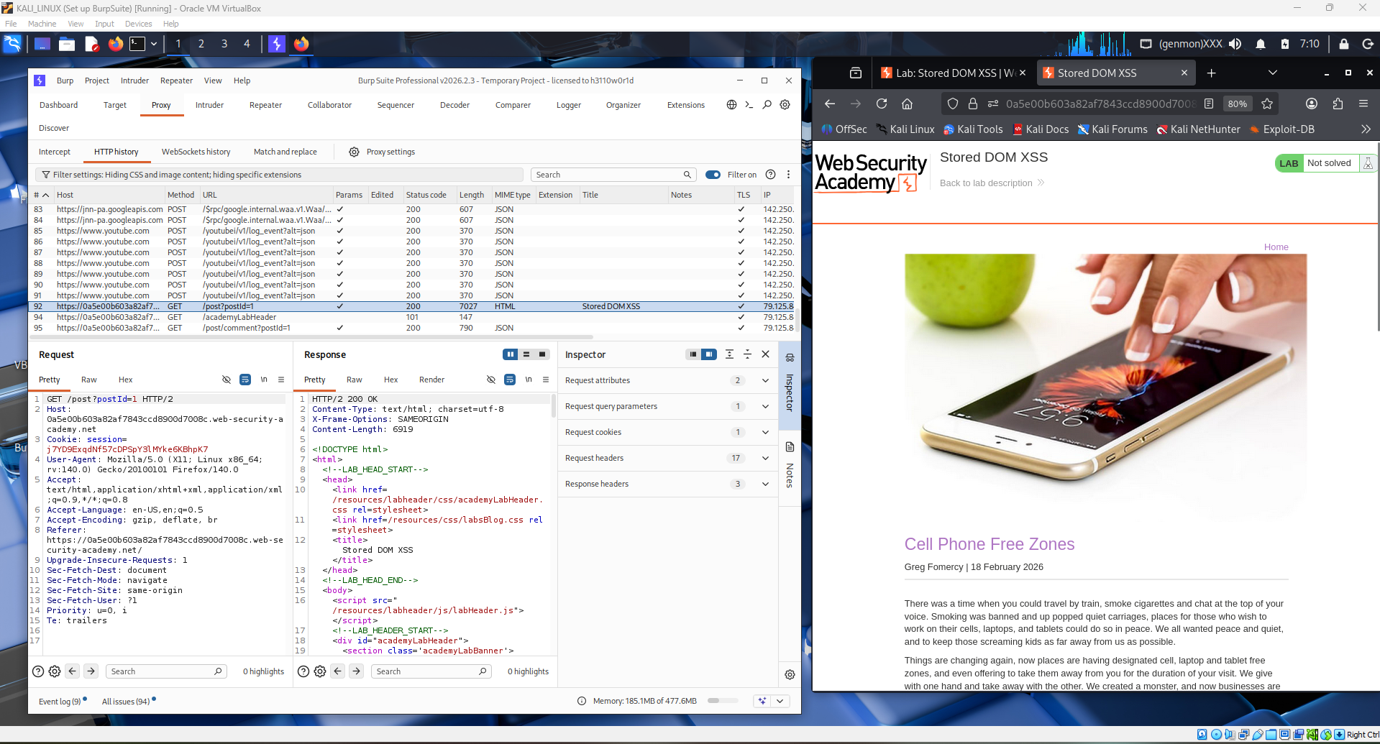
The left side shows Burp Suite analyzing a selected HTTP request and response in detail, helping identify how input is handled by the application, while the right side displays the lab instructions explaining the Stored DOM XSS vulnerability and suggesting a payload to inject into the comment field in order to trigger JavaScript execution.
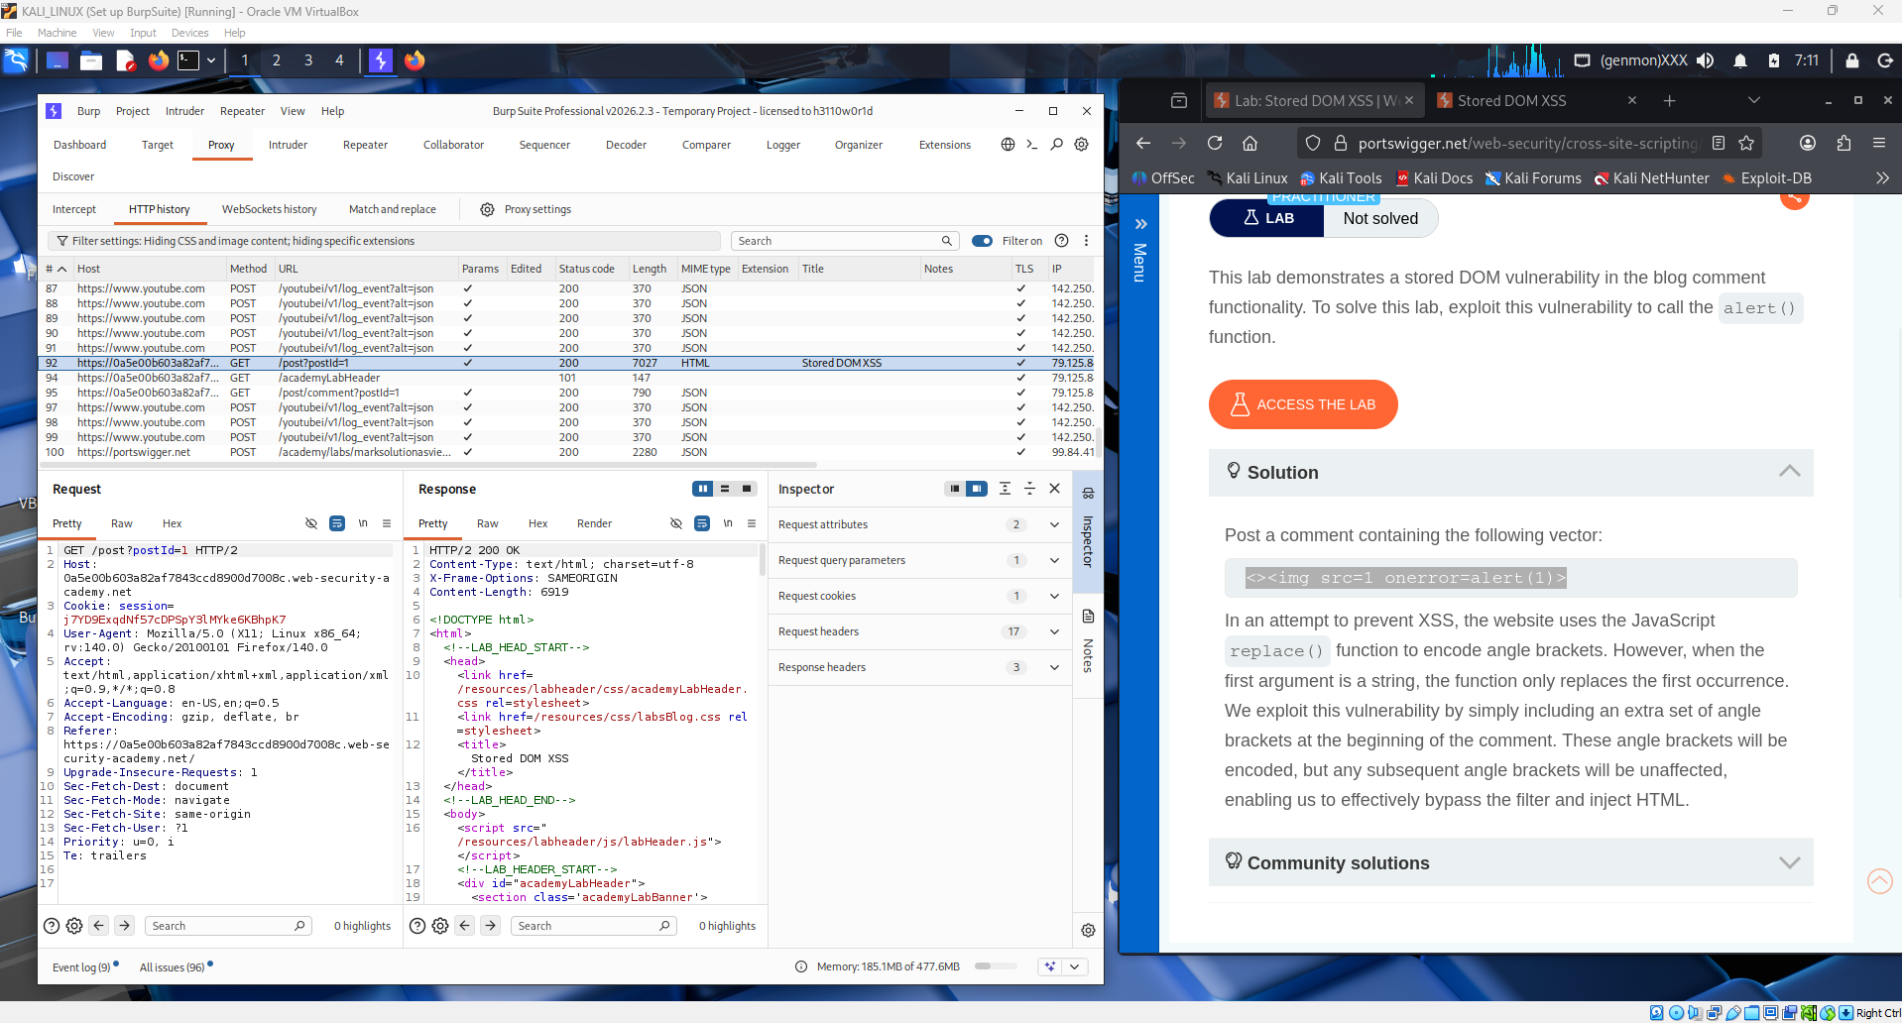
The left side shows Burp Suite capturing and analyzing HTTP traffic, while the right side displays the comment section of the blog where a malicious XSS payload has been inserted into the input field, demonstrating the step of injecting a script to exploit the Stored DOM XSS vulnerability before submitting the comment.
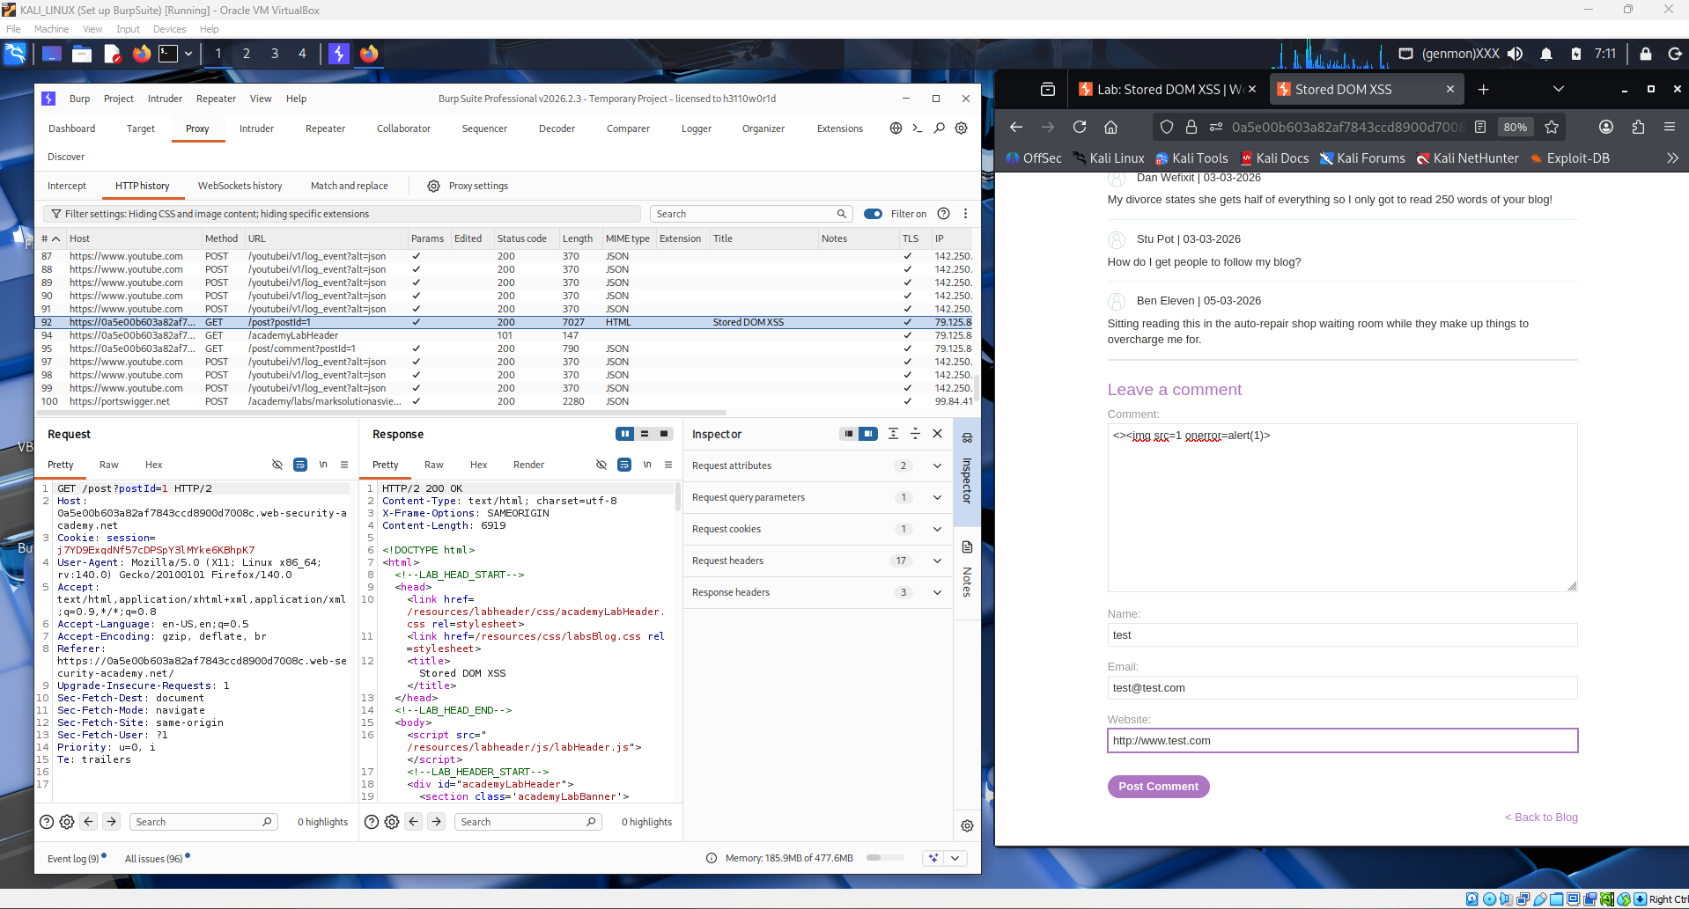
The left side shows Burp Suite's HTTP history with a highlighted POST request to /post/comment returning 200 OK, confirming the XSS payload was successfully submitted. The right side displays the PortSwigger lab page showing "Thank you for your comment!", indicating the malicious script has been stored in the server's database and the attack was successful.
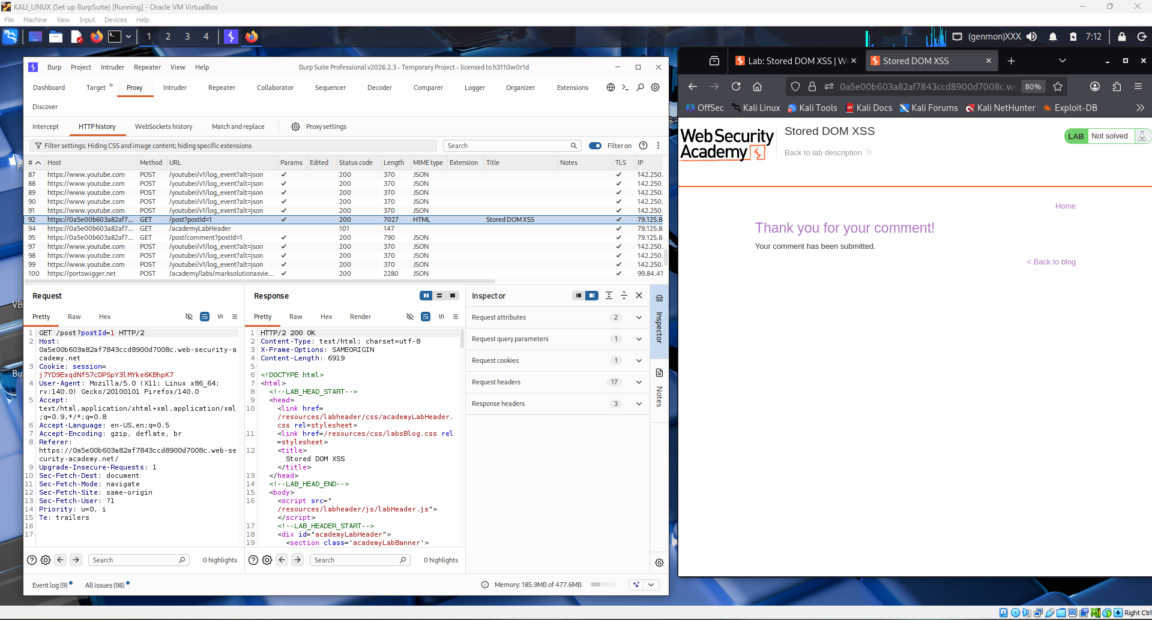
The left side shows Burp Suite's HTTP history with a highlighted GET request to / returning 404 Not Found, and the Response panel displays "Not Found" in JSON format, suggesting the XSS payload triggered a script that attempted to fetch a non-existent resource. The right side shows the blog page has loaded with a browser alert popup from the lab domain, confirming that the stored XSS payload was successfully executed when the page was visited.
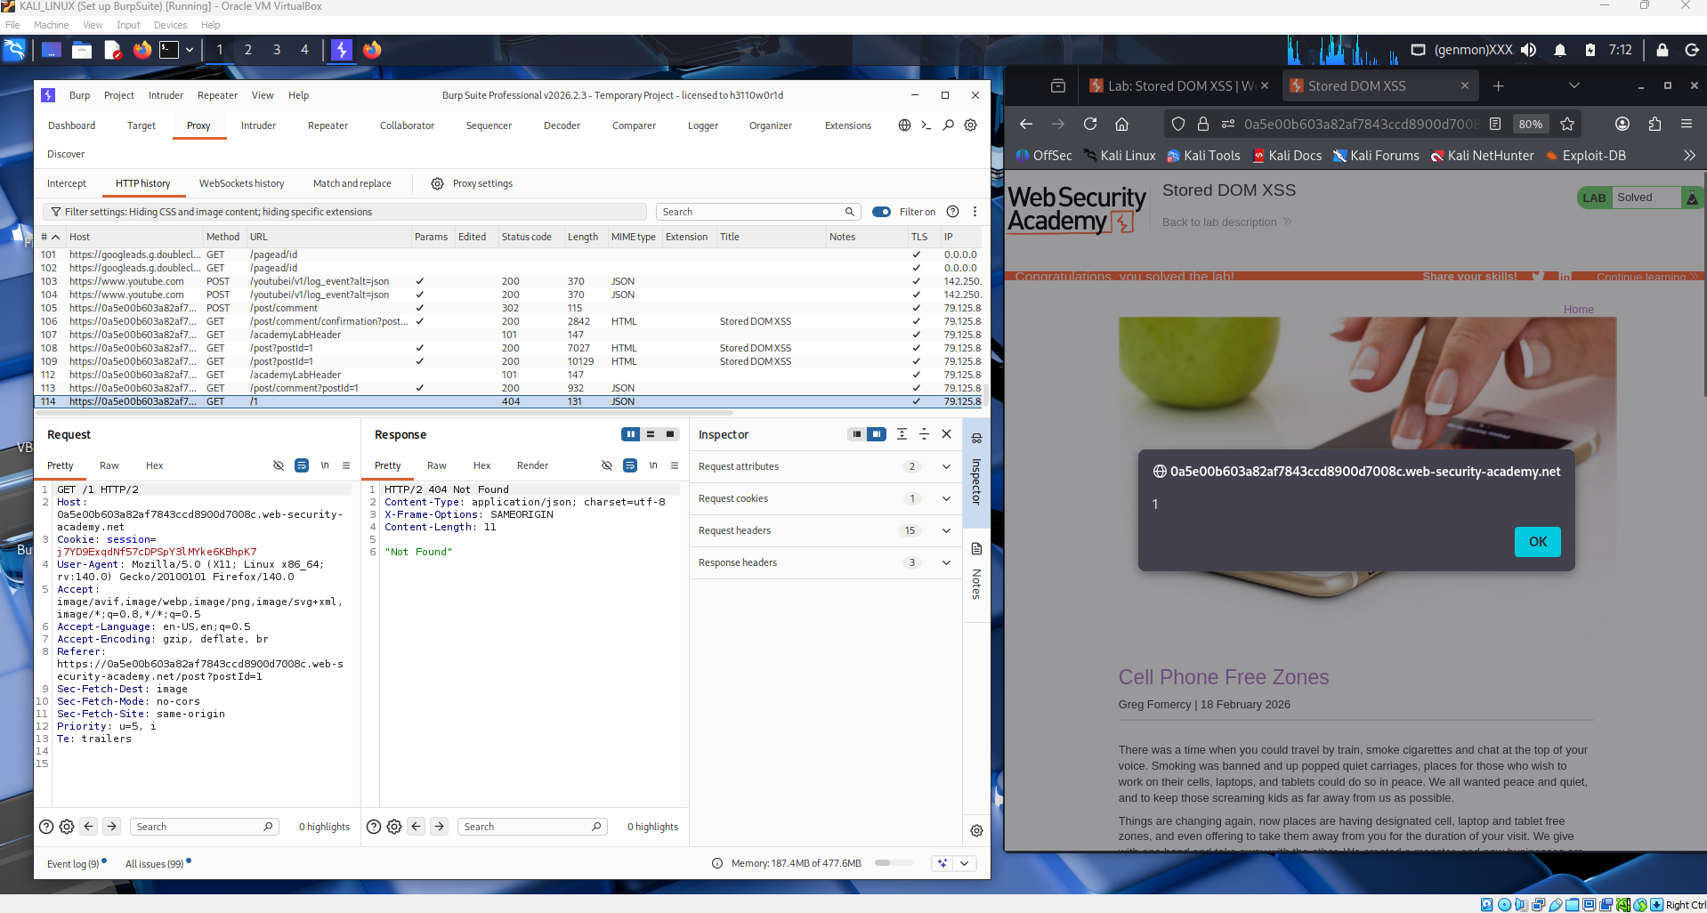
The left side shows Burp Suite still capturing the same GET request to / with a 404 Not Found response, confirming the XSS payload successfully executed and made an unintended request to the server. The right side displays the "Congratulations, you solved the lab!" banner on the PortSwigger page, marked as Solved, confirming the Stored DOM XSS challenge was completed successfully.
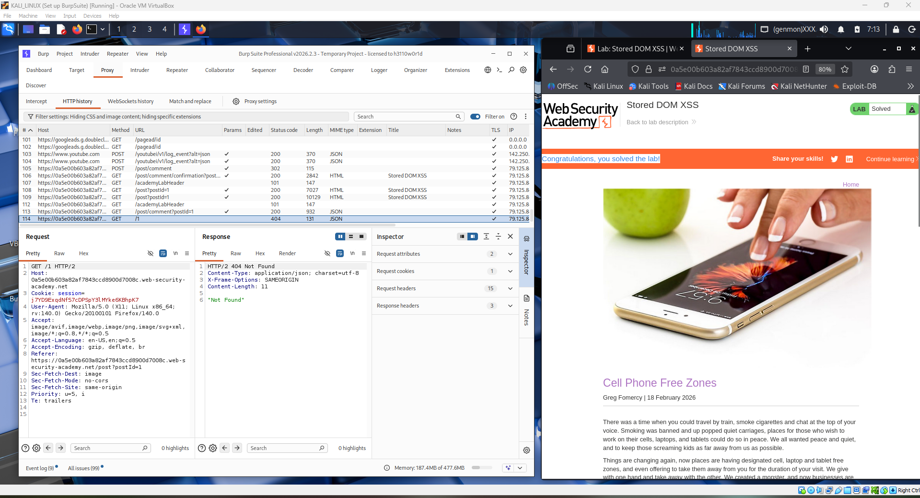

Question 1: What defines Stored XSS, and how does it differ from Reflected XSS and DOM-Based XSS?
Stored XSS (Persistent XSS) occurs when an attacker injects a malicious script into a web application that is then permanently saved on the server (e.g., in a database, comment field, or message board). The script executes automatically every time any user loads the affected page, without requiring any further action from the attacker.
Differences:
 | Stored XSS | Reflected XSS | DOM-Based XSS
Storage | Persisted on server | Not stored | Not stored
Trigger | Any user visits the page | Victim clicks malicious link | Client-side script processes malicious input
Target | All visitors | Single victim | Single victim
Persistence | Permanent until removed | Temporary | Temporary
Location | Server-side (DB) | HTTP response | Browser DOM

Question 2: How are malicious scripts injected, stored, and executed in Stored XSS attacks, and what are the consequences?
Process:
- Injection — The attacker submits a malicious payload (e.g., <script>alert(1)</script>) through an input field such as a comment box, username, or profile field.
- Storage — The server saves the payload into the database without proper sanitization or encoding.
- Execution — When any user visits the affected page, the server retrieves and renders the stored payload as part of the HTML, causing the browser to execute the script automatically.
Consequences:
- Session hijacking — Attackers steal session cookies to impersonate authenticated users.
- Credential theft — Fake login forms can be injected to capture usernames and passwords.
- Malware distribution — Users can be silently redirected to malicious external sites.
- Defacement — The visual content of web pages can be altered or destroyed.
- Data exfiltration — Sensitive user data can be silently sent to attacker-controlled servers.
- Reputation damage — Organizations suffer loss of user trust and potential legal liability.

Conclusion
This lab demonstrated the real-world danger of Stored DOM XSS, where a malicious script injected through a comment field was permanently stored on the server and executed in every visitor's browser via unsafe DOM manipulation. Unlike Reflected or DOM-Based XSS, Stored XSS is particularly severe because it does not require the victim to click a specific link — simply visiting the compromised page is enough to trigger the attack. To prevent such vulnerabilities, developers must enforce strict input validation, output encoding, and adopt secure coding practices such as using textContent instead of innerHTML when rendering user-supplied data on the client side.

